Friday, February 16, 2018, 12-1:30 pm
HSSB 4020

The French Political Royal Mistress and the Gallic Singularity
Tracy Adams, European Languages and Literatures
University of Auckland, New Zealand

We are so used to the idea of the royal mistress as a constituent element of the French king’s grandeur that we tend not to think about how strange it is that in Ancien Régime France nine women who were not part of the royal family exercised significant political influence, their position imagined as part of a “tradition” and its occupants perceived as a coherent group. Although kings throughout medieval and early modern Europe had extra-conjugal sexual partners, only in France did the politically powerful royal mistress become a quasi-institutionalized position.

How did this happen? The position could not exist until imagined as part of a larger system of royal representation. In this paper, from a co-written work-in-progress entitled The French Royal Mistress and the Politics of Representation, I suggest that the key moment comes when the royal family, traditionally assimilated with the Holy Family, began to be assimilated with the more fluidly composed family of classical deities. Focusing on the period between Agnès Sorel (1422-1450), whose representation as the Virgin Mary can only be described as a “one-off” and the Duchess of Etampes (1508-1580), who performed her role with François I in the “theater” of Fontainebleau where massive frescoes drawn from classical mythology provided a gloss for her career, I draw attention to the convergence of theatrical reading practices and renewed interest in the chaste but fierce huntress Diana that made the role of politically powerful royal mistress thinkable.
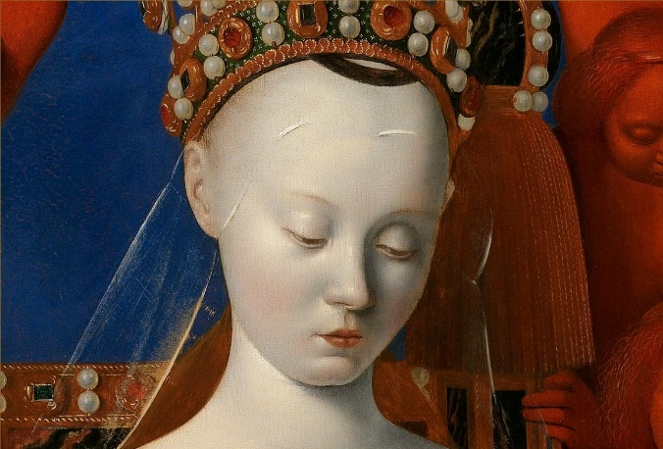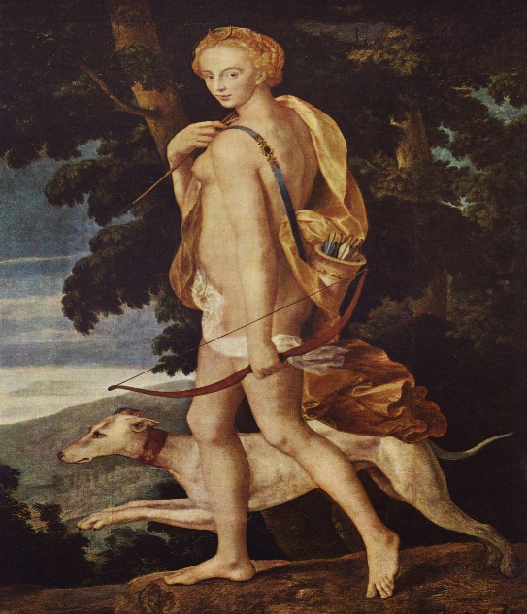
Jean Fouquet, The Virgin/Agnes Sorel, c. 1452 Diana the Huntress (mid-16th c.)

