“Students learn from people they love!”
Stephen Murphy-Shigematsu, Stanford University, January 23, 2019
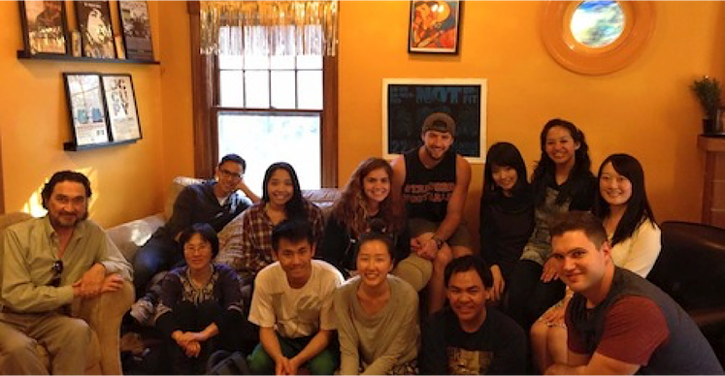
“Students learn from people they love.” The title of the article in The New York Times (1/17/2019) struck me in many ways. First, with great interest. Yes! I’ve believed this for years. Then, as I read, I felt assurance that the article by David Brooks was based on his personal experience as well as scientific research. I recalled voices of other educators who have written about this. Then I heard the cynical voice of teachers who have told me that this is a dangerous way to be with students. Finally, I felt renewed in my belief that we must teach in this way, so I am moved to write.
Following the work of people like bell hooks and Arthur Zajonc I have promoted love as the pathway to good teaching. hooks called teaching “an act of love” and Zajonc reminded us that the true heart of education is loving what we study, as we come to know best that which we love the most. He is a physicist and shows us how this is as true for kindergarteners as for Nobel Prize winning scientists.
My personal experience as a teacher working with the full range of humans, from infants to seniors, also tells me that this is so. The key to good teaching is to bring yourself as a human being into the classroom. This simple act can create beginner’s mind, opening the door to vulnerability and authenticity, leading to the creation of a safe space for discovery.
But this is just what many teachers fear and resist. “Leave yourself at the door,” some warn. For them, this is the way to be a teacher who is objective, focused on reason, without emotion, only teaching skills, information. Make it safe for yourself and students by keeping it intellectual, cognitive, rational, analytical, critical. This dreary vision of teaching as “dispassionately downloading knowledge into students’ brains” is something I cannot do. As the NYT article suggests, I believe that we need to put relationship quality at the center of education.
Neuroscience research reminds us that emotions can inform reason rather than overwhelm it. Good teaching opens the hearts and minds of students, giving them new things to love — ideas, insights, discoveries, but also people. Like parents, what teachers really teach is to present themselves as imperfect and compassionate human beings, and this can include our love of subjects, as well as for our students. Scientific evidence reminds us of the truth that many teachers have witnessed over and over again -- children learn from people they love and who love them as a whole person.
The approach I call Heartfulness includes mindfulness, compassion, and responsibility. More and more educators are teaching in ways that help students to come alive, focus and calm themselves, cultivate greater emotional, social, and ecological intelligence, and develop their creativity. Teaching from the heart reaches the hearts of students, enabling introspection into meaning, ethics, purpose, and values, encouraging students’ reflections on their internal experience as well as their connectedness with others. In this humble way, we build healing communities one person at a time.
from Murphy-Shigematsu’s “Heartfulness” blog: https://www.murphyshigematsu.com/single-post/2019/01/23/%E2%80%9CStudents-learn-from-people-they-love%E2%80%9D?utm_campaign=e8f9c140-9d45-4478-981b-17579408566b&utm_source=so

