LEARN AT LUNCH:

Atheism and Unbelief in the Protestant Atlantic World, c. 1558 - c. 1776
Patrick Seamus McGhee, University of Cambridge (UK)

THURSDAY MAY 2, 1-2:15 HSSB 4041

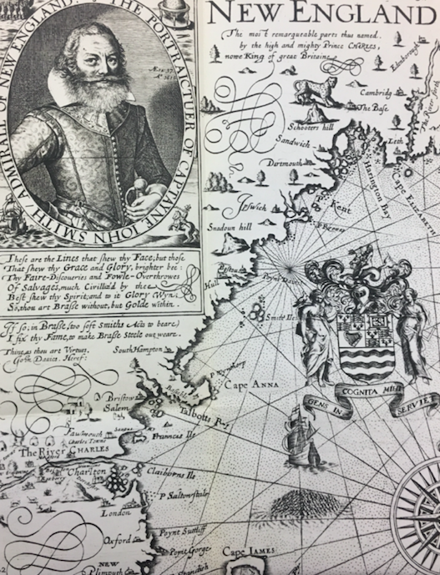

Focusing on colonial New England from the early settlements of the 1620s to the eve of the American Revolution, this talk explores how religious believers confronted 'atheism' and 'unbelief' within others and themselves. Charting the development of Congregationalism and the emergence of Pietism, the writings of the Mather ministers dating from c.1645 to c. 1722 suggest that the problem of non-belief shaped the cross-generational evolution of colonial approaches to magic, medicine, and the cosmos.

Meanwhile, the work of the first published African American poet Phillis Wheatley (1753-1784) illuminates the spiritual dimensions of writing about atheism as a way of expressing and
reconfiguring Christian identity itself. Investigating the rich variety of non-Christian categories discussed among poets and preachers, pilgrims and planters, the talk seeks to demonstrate that textual and material responses to 'atheism' and 'unbelief' were entangled with Christian attitudes towards enslaved peoples, the spiritual lives of
colonial women, and efforts to convert indigenous groups, in ways that
not only reflected but also informed religious doctrine, experience, and
identity.

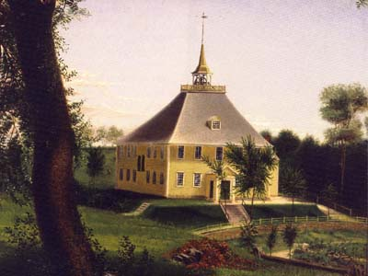

Mr. McGhee is a fourth-year AHRC doctoral candidate in early modern History at Cambridge (UK). He completed his undergraduate degree in History at the University of Birmingham and his Master’s degree at the University of Cambridge. His doctoral work focuses on 'Heathenism' in the Protestant Atlantic World, c. 1558 - c. 1700. He is presently a fellow at the Huntington
Library in San Marino, CA, where he is exploring colonial attitudes towards doubt, atheism, and unbelief within the community of believers.

LUNCH PROVIDED

