FEB 5 12-1:30 pm: Reinterpreting Slavery and the Emotional Labor of History
Hilary Green, Univ. of Alabama

Webinar Registration Link
https://ucsb.zoom.us/webinar/register/WN_yzLVlQ62QNGv7sZz1DenDA

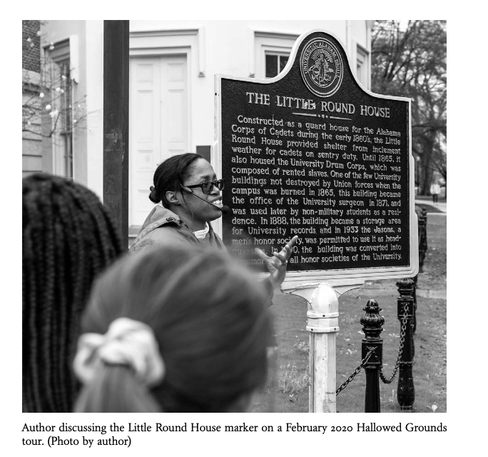

Image courtesy of The Public Historian.
Prof. Green reflects on the powerful legacy of Jim Crow era efforts to erase the history of slavery from the landscape of her workplace, the University of Alabama, and shares a project she pursued to rewrite this historical narrative. She researched, designed and implemented a campus tour to tell the actual history of slavery and enslaved workers in the University’s past. She collected oral tradition and pursued deep archival research, to historicize “the experiences, activism and collective memories of African American men, women and children,” and describes her efforts to get the campus community to rethink its understanding of the past, even as an untenured member of the faculty. Her project exposed the racist structures undergirding the University Archives; it highlights the tenacity of older narratives and exposes some of the physical and psychological burdens of this sort of historical recuperation for the practitioner. All this unfolded in the larger social struggle over historical monuments and commemoration in recent months. As Green writes, “when exploring the racial history of one’s employer, the Jim Crow era archival project of white supremacy is no longer an abstract concept read about only in scholarship.”

Hilary Green is Associate Professor of History at the University of Alabama.
About the speaker: https://www.hngreenphd.com/

Recommended: Hilary Green, “The Burden of the University of Alabama’s Hallowed Grounds,” The Public Historian 42: 4 (November 2020): 28-40.

Save the date for the next in our series:

Trevor Getz, San Francisco State Univ.
MAR 5, 12-1:30: Abina and the Important Men: Graphic History as Public History

