History 129Q
For whom did the Bayle Toil?
Paul Sonnino
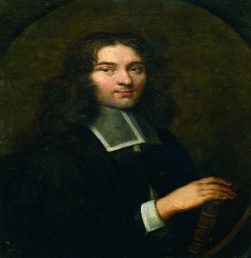
Pierre Bayle (1647-1706) was one of the most controversial thinkers of the so-called “Enlightenment.” Accused of being
everything between an atheist and a joker, he insisted that he was neither but, rather a devout Calvinist refugee from the religious persecution of Louis XIV. In 1696 he began publishing his Historical and Philosophical Dictionary, which was read in shock by everyone who wanted to figure him out, a kind of 17th 18th century Howard Stern.
In this course we are going to read four articles from his huge dictionary and see what we can make of him and the time in which he was living.
The main purpose of this course, however, is to teach you how to become a great historian in nine weeks of distance learning. We do this by going over each of the four articles, carefully discussing them on Zoom , after which you write short papers on them that I will correct and use them to try to teach thought by thought and sentence by sentence how to think and how to write. That is tantamount to person-to-person tutoring if you are interested in learning something.

