JAN 15, 12-1:30: UCSB Department Colloquium in Public History

Public Lands, Public History: Putting History to Work for the United States Forest Service
Leisl Carr-Childers and Michael Childers, Colorado State Univ (Ft. Collins)
(Jt Session with Science/Technology Colloquium)

Registration Link
https://ucsb.zoom.us/webinar/register/WN_Wty4lxPTR-eCkgVxoKfSYQ

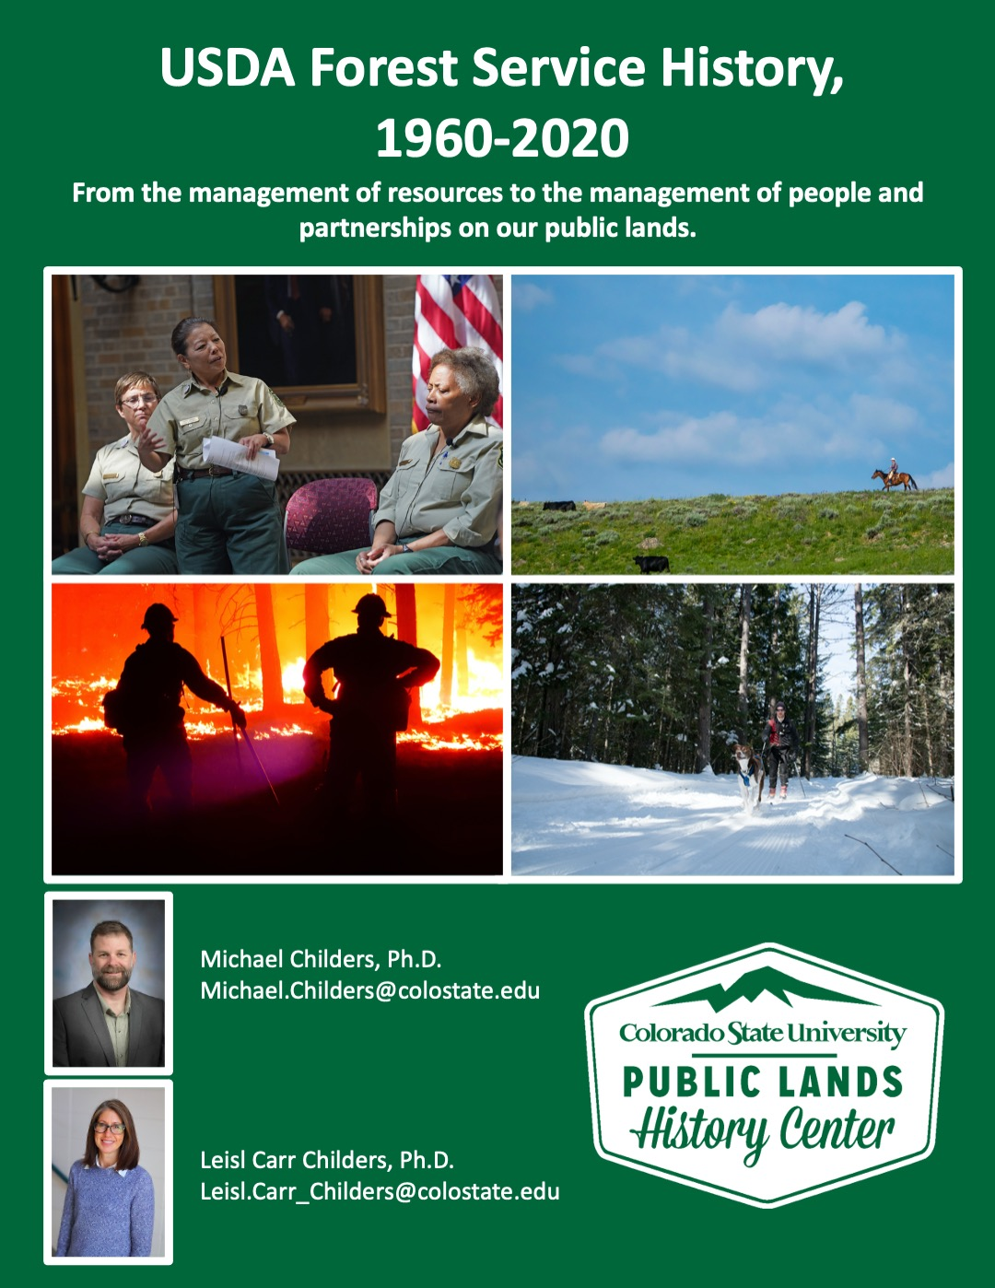
Childers and Carr Childers will discuss their current project, a new history of the USDA Forest Service from 1960-2020, and the historical methodologies that undergird their work. In particular, they will address what it means to work in applied history, how applied history works (or does not work) with regard to public lands management agencies, and how public history, applied history, and working as a public intellectual speaks to history taking a public turn.

Recommended Readings:

Bundyville, Season ONE—podcast
(applied history work by Leisl Carr-Childers)
https://longreads.com/bundyville/season-one/

Imperiled Promise: The State of History in our National Parks
https://www.oah.org/site/assets/files/10189/imperiled_promise.pdf

Patricia Limerick, “Applied History, Knocked for a Loop but Neither Down Nor Out,” and “Where Bipartisanship Finds a Refuge: A Rendezvous with the Western Governors’ Association,” both in her “Not my first Rodeo” blog:

https://www.centerwest.org/archives/23851

https://www.centerwest.org/archives/23429

About the speakers:
- https://libarts.source.colostate.edu/csu-faculty-writing-history-of-the-modern-u-s-forest-service/
- https://leislcarrchilders.org
- https://michaelwchilders.com/author/michaelwchilders/

