The Departments of History and French and Italian, the Early Modern Center, the Hull Chair in Women’s Studies, and the Interdisciplinary Humanities Center are pleased to announce:

Professor Sara Beam
Department of History, University of Victoria

“Missing Babies and Tacit Tolerance of Infanticide
in Early Modern Europe”

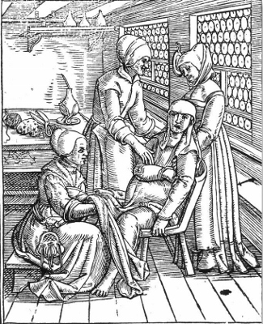

Friday, 28 February 2020 at 3:30 p.m. in HSSB 4080

Aggressive criminal prosecution of unwed mothers who killed their newborns in early modern Europe (1550-1750) has led scholars to assume that Europe was less tolerant of illegitimacy and infanticide than other pre-modern societies, including China and Japan. New research throws this assumption into question. In early modern Geneva, authorities often turned a blind eye to the untimely deaths and abandonment of unwanted bastards. These findings suggest that Europeans took a more practical approach to managing fertility than we had thought.

