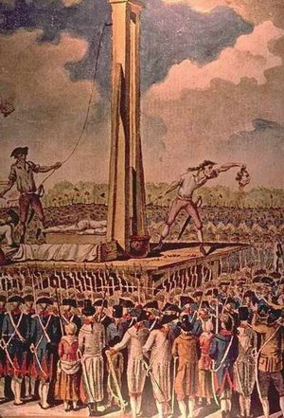**Europe and the Crisis of Modernity: 1715-Present**

**History 4C – Spring 2018**

**T/Th: 9:30-10:45**

**Professor Erika Rappaport**

**Office: HSSB 4252**

# E-mail: rappaport@ucsb.edu

**Hours: Tuesdays 11:15-1:15 or by appointment**

**THEMES AND OBJECTIVES:**

During the past three hundred years Europeans have experienced unprecedented changes in their economy, society, culture, and politics. Through lectures, readings, and discussions this course will explore how men, women, and children experienced these revolutionary upheavals. We will particularly examine how individuals, families, and communities responded to and brought about a society that came to see itself as "modern." Themes will include the nature of revolution, industrialization and urbanization, the growth of nationalism and imperialism. We will also trace the demise of European global dominance through two catastrophic world wars, revolutions and economic crises, and anti-colonial movements in Africa and Asia and recent resurgent nationalism and xenophobia expressed in far right parties across Europe. Two related questions we will be exploring will be the connection between “modernity” and violence and the on-going struggle between liberty and security that emerges in public and private debate at key moments in modern European history. This course will familiarize you with historical methods and writing. A heavy importance will be placed on reading primary historical documents (memoirs, speeches, and other first-hand accounts), new works of historical scholarship, and writing analytical essays.

**REQUIRED READINGS** In addition to documents and articles available on the course website (Gauchospace), the following books are available at the UCSB, are on course reserve in the library, **and a free e-version of Forth and Jobs will also be available thanks to the UCSB Sustainability Office.**

1. Joshua Cole, Carol Symes, *Western Civilizations: Their History and Culture* vol. II, Brief Fourth Edition (Norton 2015)

2. [Aidan Forth, *Barbed-Wire Imperialism: Britain’s Empire of Camps, 1876-1903* (University of California Press, 2017)](https://ucsb-primo.hosted.exlibrisgroup.com/primo-explore/fulldisplay?docid=TN_jstor_booksj.ctt1tqx74m&context=PC&vid=UCSB&lang=en_US&search_scope=default_scope&adaptor=primo_central_multiple_fe&tab=default_tab&query=any,contains,barbe%20wire%20imperialism&sortby=rank&offset=0)

3.[Richard Ivan Jobs, *Backpack Ambassadors: How Youth Travel Integrated Europe* (University of Chicago Press, 2017)](https://ucsb-primo.hosted.exlibrisgroup.com/primo-explore/fulldisplay?vid=UCSB&search_scope=default_scope&tab=default_tab&docid=01UCSB_ALMA51305243930003776&lang=en_US&context=L&adaptor=Local%20Search%20Engine&query=any,contains,backpack%20ambassadors&sortby=rank)

**COURSE REQUIREMENTS:**

1. (10%) Attendance and participation in section discussion and completion of section assignments. You must be enrolled and attend a discussion section to pass the course. Sections are your time to discuss the reading. Your TA will assign section work that is designed to encourage you to do the reading and participate in course discussion. Please note that m**issing more than 3 sections will result in a fail in class.**

2. (50%). (Two papers, 900 words each). This course meets the university writing requirement (1,800 words). Students will be turning their papers in electronically and will also turn a hard copy to their TA in lecture on April 23 and May 21. The first paper will be on the French Revolution and will be based on primary documents; the second paper will be an analysis of Aiden Forth’s *Barbered-Wire Imperiallism.*

3. (40%) – Final Exam, Tuesday, June 12: Students who need an alternative time for the exam may sign up for make-up exam, which will be scheduled on June 8th. Please tell your TA as soon as possible if you need to take the alternate final. The final exam will be comprehensive and cover material from all the lectures and textbook reading, and *Backpack Ambassadors*

5. (up to 4%) Extra Credit: You may read and summarize one of the available articles that will be available on Gauchospace. Each summary would be worth up to 2 pts out of (100 for the class). You may do two of these. They are due on Gauchospace by Friday at midnight the week they are listed.

**READING:**

-- Students should read the assigned work **before** the appropriate section meeting. The textbook is designed to give you an overview of the topics covered in lecture and to provide you with the background to understand the documents and/or other books. You will discuss the primary documents in each chapter in the discussion sections.

**ETHICS:**

**Cheating**: The following statement is official university policy and will be adhered to in this course: “The core of a university's integrity is its scholastic honesty. Academic dishonesty vitiates the university's educational role and defrauds all who comprise its community. It is expected that students understand and subscribe to the ideal of academic integrity and are willing to bear individual responsibility for their work. Materials submitted to fulfill academic requirements must represent a student's own efforts. Any act of academic dishonesty, such as plagiarism or other forms of cheating, is unacceptable and will be met with disciplinary action.”

**Late Papers:** Students may only turn in late papers if the TA gives permission at least 24 hours in advance. However, they will be marked down a full grade for every 24 hours the paper is late.

**Computer Policy:** No surfing the web, checking email, texting, or otherwise using electronic devices. You may take notes on your lap top computer, but you will be asked to sit in the first 5 rows of class.

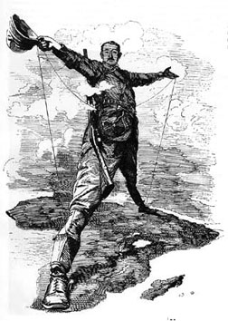**Lecture and Reading Schedule**

**Week 1: IMAGINING THE OLD REGIME**

**4/3**: Course Introduction

**4/5:** Order and Disorder in the Old Regime

**Reading: Cole and Symes, Chapter 17**

**Week 2: THE FRENCH REVOLUTION**

**4/10**: The Coming of the French Revolution

**4/12:** The Revolution Unfolds

**Reading: Cole and Symes, Chapter 18**

**Discussion Sections:** Primary Documents from Chapter 17 and 18 in text, Rousseau’s Social Contract (1762), p. 463 and Rousseau and his Readers, p. 464-65, and PDF of selected documents available on Gauchospace. These documents are the evidence you will use to write your first paper.

**Week 3: REVOLUTION ENGLISH STYLE**

**4/17**: England and the “Industrial Revolution”

**4/19:** Classes and their Cultures

**Reading: Cole and Symes, Chapter 19**

**Week 4: THEORIES OF SOCIETY, POLITICS AND ECONOMY – *Papers due April 23 by Midnight turn in on Gauchospace***

# 4/24 -- Conservatism and its Enemies

**4/26**-- Nations and Nationalism

**Reading: Cole and Symes, Chapters 20 and 21**

**Forth, *Barbed-Wire Imperialism: Britain’s Empire of Camps, pp. 1-43***

# Week 5: MASS ANXIETIES

**5/1:** Culture, Society and Economy in the Fin-de-Siècle

**5/3**: Living and Dying in the Modern City

**Reading:**

**Forth, *Barbed-Wire Imperialism pp. 43-185***

**Cole and Symes, Chapter 23**

**Week 6:** **A NEW CULTURE OF GLOBAL VIOLENCE**

**5/8**: The New Imperialism

**5/10**: Death in the Trenches

**Forth, *Barbed-Wire Imperialism: pp 212-227***

**Reading: Cole and Symes, Chapter 22 and 24**

**Week 7: AN IMPERIAL WAR?**

**5/15: The Women’s War**

**5/17: The War Remembered, *Gallipoli***

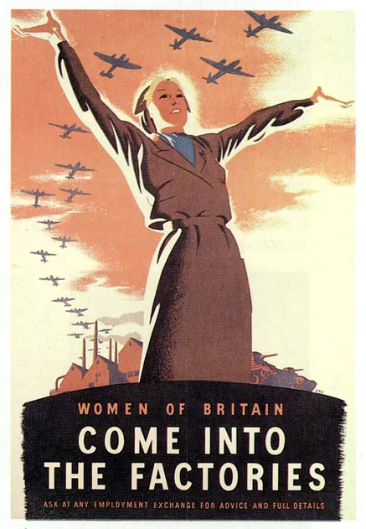

**Week 8: REVOLUTIONS, AGAIN...**

***5/21 Paper Two due on Gauchospace by Midnight.***

**5/22**: The Russian Revolution

**5/24** : The Fascist Revolution

**Reading: Cole and Symes, Chapter 25**

**Richard Ivan Jobs, *Backback Ambassadors: How Youth Travel Integrated Europe, 1-97***

**Week 9: TOTAL WAR**

**5/29**: The People’s War: Myths and Realities

**5/31**: Unity and Disunity in Postwar Europe

**Reading: Cole and Symes, Chapter 26**

**Jobs, *Backback Ambassadors, 97-193***

**Discussion Sections this week will watch *Night and Fog***

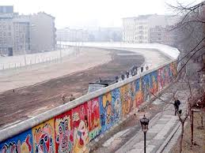

**Week 10: A NEW EUROPE?**

**6/5:** From the Cold War to the New Europe

**6/7 :** From Brexit to the Burkini: Fascism returns?

**Reading: Cole and Symes, Chapter 27, 28 and 29**

**Finish Jobs, *Backback Ambassadors, 97-193***

**Final Exam: Tuesday June 12th: 8-11 am. Alternate Final Exam, Monday June 11th: 9-12 am-- place to be announced.** This option is for a limited number of students, who have been appr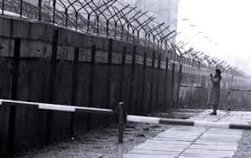oved by their TA.

